My Research Notebook

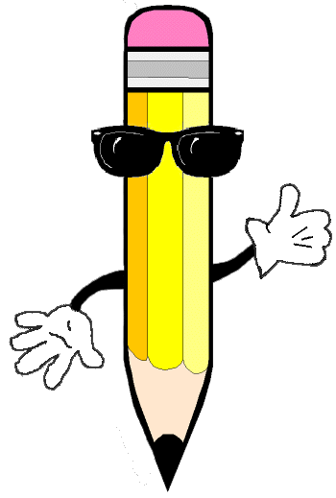

By _________________________________________

Date:_______________________________________

What I Think I Know

About the

________________

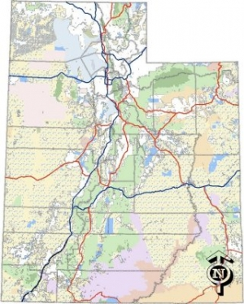Location

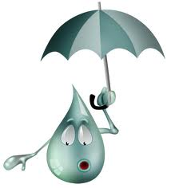Climate

Animals 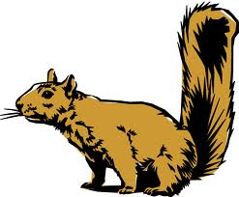

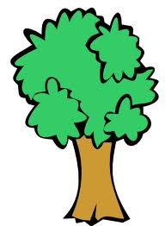Plants

Interesting Facts

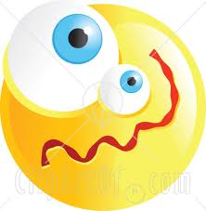Misconceptions

Wonderings